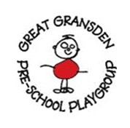
Great Gransden Pre-School Playgroup

Children’s Uniform order form
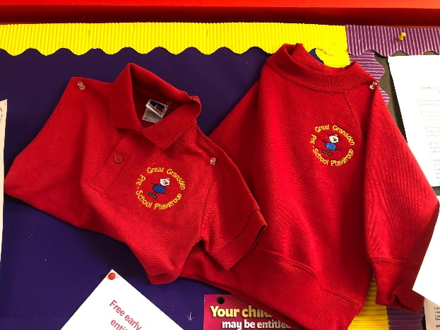

Playgroup have polo-shirts and sweatshirts with our logo embroidered on available to purchase if you wish. [optional]
Please circle your requirements below and return the sheet to a member of staff.

Polo shirt Colour - RED Quantity required? ______
£8.00
Size - 1-2 3-4 5-6

Sweatshirt Colour - RED Quantity required? ______
£8.50
Size - 1-2 3-4 5-6

Child’s name:____________________________________

Do you wish to pay cash/BACS or add to next bill? [please circle]

Playgroup staff only :- Has order been given out Y/N? Cash received?
Full or Part? Please specify.

