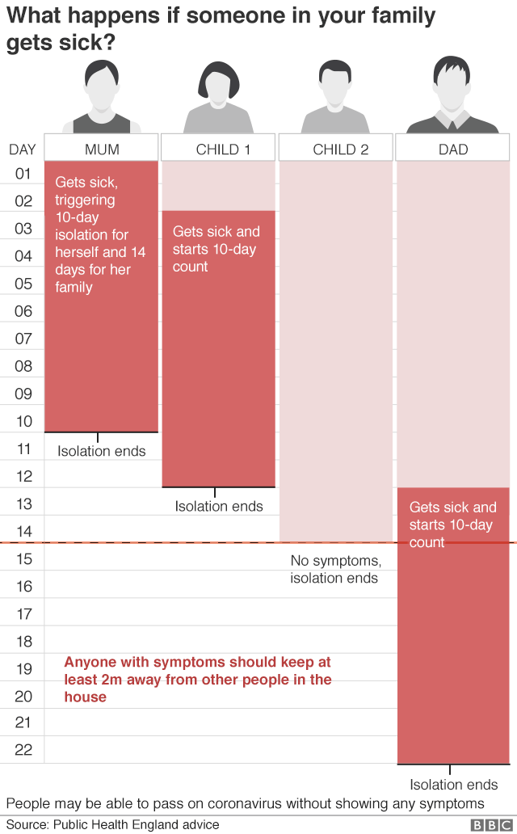

Further information can be found here:
https://www.gov.uk/government/publications/covid-19-stay-at-home-guidance/stay-at-home-guidance-for-households-with-possible-coronavirus-covid-19-infection

